System Design Document (SDD)
Hospital Management System



Submitted by
Qamar Azam
S23BINFT1M01173

Submitted to
Dr. Syed Ali Nawaz Shah

Department of Information Technology 
Faculty of Computing
The Islamia University of Bahawalpur

UNDERTAKING

We certify that research work titled “Hospital Management System” is our own work. The work has not been presented elsewhere for assessment. Where material has been used from other sources it has been properly acknowledged / referred

DEDICATION

This project is dedicated to The Planner, The Creator of the entire Universe. The Merciful ALLAH and his loving messenger Hazrat Muhammad (Peace Be upon Him). ALLAH has given us the power to perform this task and facilitating every possible means to complete this project.
After that to my family, who’s unwavering love and support have been my anchor throughout this academic adventure. And also to my advisor, (Dr. Syed Ali Nawaz Shah ) for his guidance, wisdom, and endless patience. Thank you for being my mentor.

SUMMARY

The Hospital Management System (HMS) is a web-based application that automates hospital workflows using a role-based system. It supports three users — Admin (full control), Doctor (appointments and patient records), and Patient (booking and profile management). The frontend is built in ReactJS, the backend in Django, and data is stored in MySQL or PostgreSQL, all connected through REST APIs.
The architecture is modular and scalable, making it easy to add features later. The database has two core tables — Users and Appointments — with statuses like Pending, Approved, or Canceled. However, the document is mostly high-level; key details like schemas and API docs are listed as appendices but not fully developed.

PROJECT BRIEF

PROJECT NAME Hospital Management System

OBJECTIVE
The main objective of this project is to automate hospital operations, streamline workflows, and enhance communication between administrators, doctors, and patients. The system will enable secure role-based access, allowing administrators to manage hospital data, doctors to manage patients and appointments, and patients to request, cancel, and view appointments. The system will aim for a user-friendly interface, ensuring efficient hospital management and improved patient care.

Project Started _ _ _ _March 2026_ _ _ _ _ _ _ _ _ _

Project Finished _ _ _ _ _ _ _ _ _ _ _ _ _ _ _ _ _ _ _ _ _ _

Source Language
• Python (Django for Backend)
• JavaScript (ReactJS for Frontend)

• SQL (MySQL/PostgreSQL for Database)
Source Software
• Backend: Django (Python) • Frontend: ReactJS
• Database: MySQL/PostgreSQL

• Development Environment: VS Code

Table of Contents
- Introduction….........................................................................................8
1.1 Purpose.............................................................................................. 8
1.2 Scope.................................................................................................. 8
1.3 Overview............................................................................................ 8
1.4 Reference Material ............................................................................9
1.5 Definitions and Acronyms ............................................................... 9
- System Overview..................................................................................... 10
2.1 System Use Cases and Use Case Diagrams..................................... 10
2.1.1 Use Case Diagrams......................................................................... 11
2.1.2 Admin Use Case Diagram.............................................................. 11
2.1.3 Doctor Use Case Diagram.............................................................. 13
2.1.4 Patient Use Case Diagram............................................................. 14
2.2 System Activity Diagrams ................................................................ 16
2.3 System Sequence Diagrams.............................................................. 16
- Backend Design ........................................................................................ 16
3.1 Data Description ................................................................................. 17
3.2 Data Dictionary................................................................................... 17
- Front-end / User Interface Design........................................................... 17
4.1 Overview of User Interface ................................................................ 18
4.2 Screen Images...................................................................................... 18
4.3 Screen Objects and Actions ................................................................ 19
- System Architecture ..................................................................................19
5.1 Architectural Design ............................................................................19
5.2 Decomposition Description................................................................. 19
5.3 Design Rationale................................................................…….......... 20
- Component Design/System Architecture ................................................ 21
- APPENDICES............................................................................................ 21

1. Introduction

1.1 Purpose
This System Design Document (SDD) outlines the design of the Hospital Management System (HMS), detailing all aspects of its architecture, design, and user interfaces. The purpose is to automate hospital workflows, making processes efficient, secure, and easy to manage.

1.2 Scope
The scope of this system covers:
- Role-based Access for Admin, Doctor, and Patient.
- Appointment Management for scheduling and approving appointments.
- Profile Management for users to update personal details and password.
- Secure Authentication to prevent unauthorized access.
- Scalability to support hospitals of any size.

1.3 Overview
The HMS integrates key hospital operations and workflows, streamlining tasks through automation. The system aims to:
- Simplify appointment scheduling.
- Improve communication between patients and healthcare providers.
- Provide robust tools for managing patient records and hospital data.

1.4 Reference Material
- Medics Documentation: www.medisys.com/documentation
- Care Cloud System Features: www.carecloud.com/features
- ReactJS Official Documentation: reactjs.org/docs
- Django Framework Documentation: docs.djangoproject.com
- MySQL Developer Guide: dev.mysql.com/doc

1.5 Definitions and Acronyms
- HMS: Hospital Management System
- Admin: System administrator with full privileges.
- Doctor: A medical practitioner managing patient data.
- Patient: A person receiving medical care, able to manage appointments.

2. System Overview

2.1 System Use Cases and Use Case Diagrams

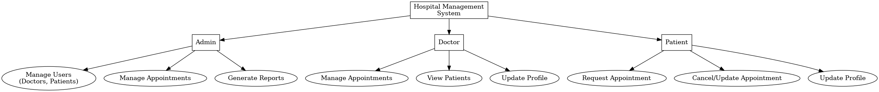

2.1.1 Use Case Diagrams
In this section, we provide detailed UML Use Case Diagrams for Admin, Doctor, and Patient.

2.1.2 Admin Use Case Diagram
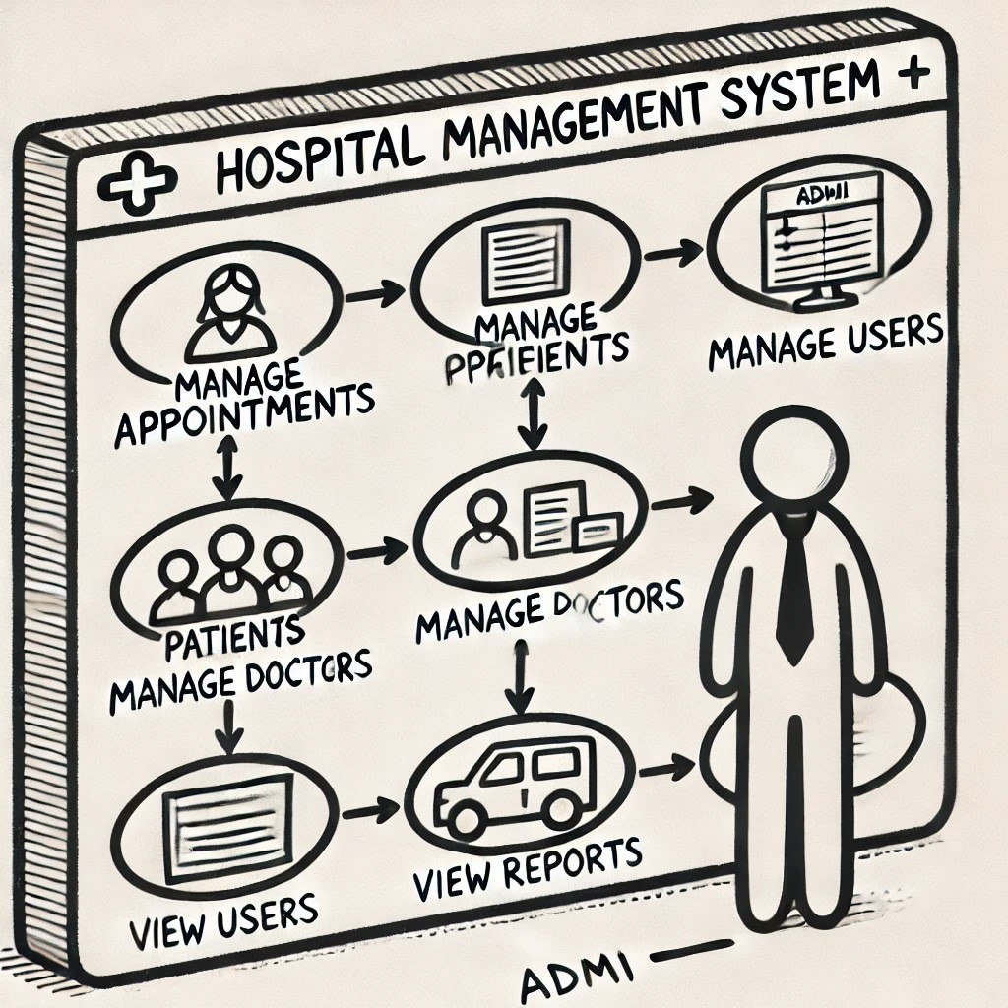

The Admin interacts with the system for:
- Managing users (Doctors, Patients).
- Managing appointments.
- Generating reports.

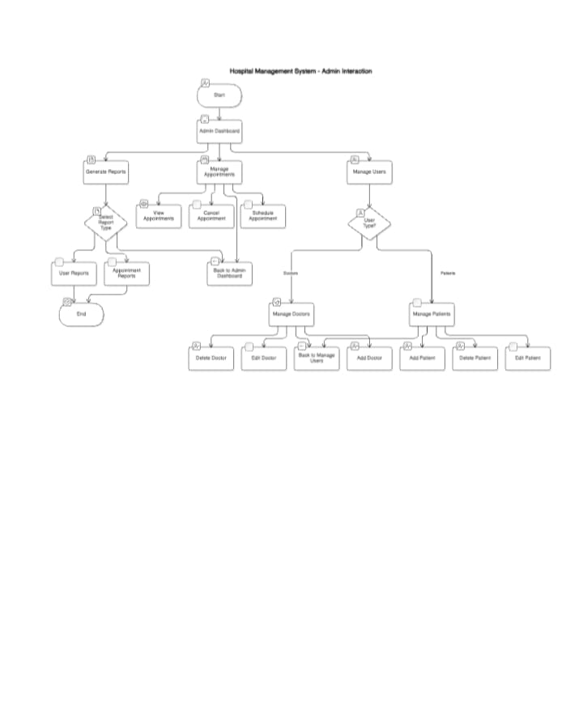

2.1.3 Doctor Use Case Diagram
The Doctor can manage appointments and patients.

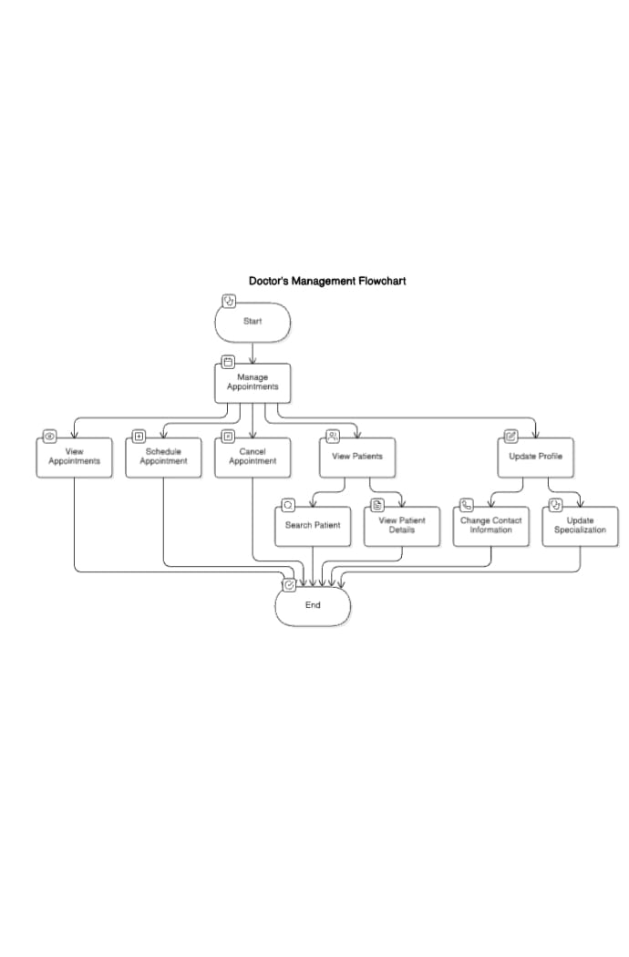

2.1.4 Patient Use Case Diagram

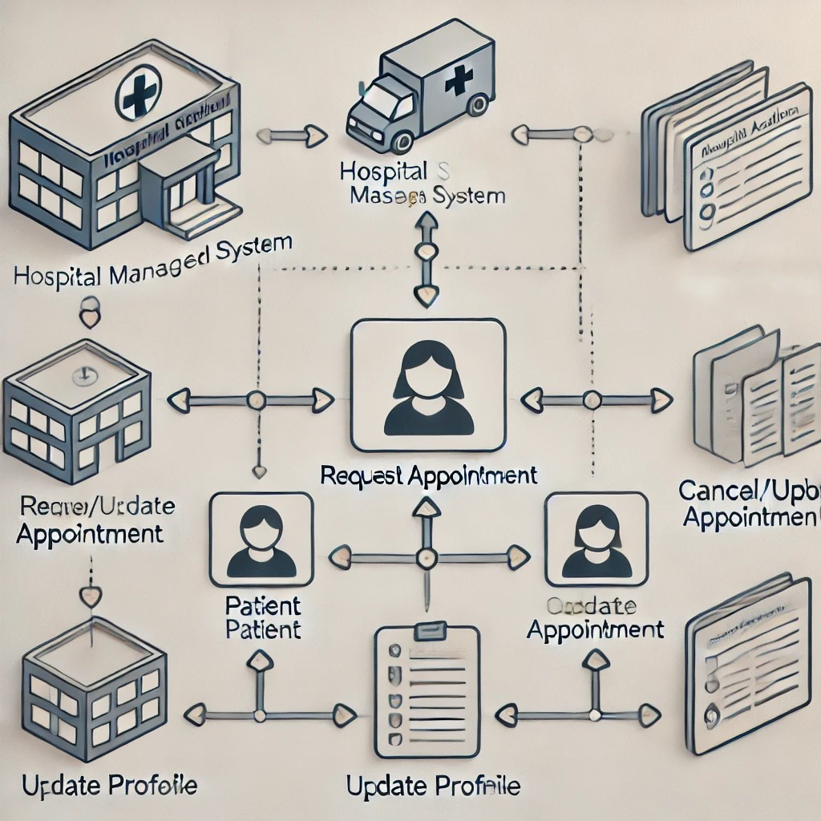

The Patient interacts with the system to:
- Request appointments.
- Cancel or modify appointments.
- Update personal profile details.

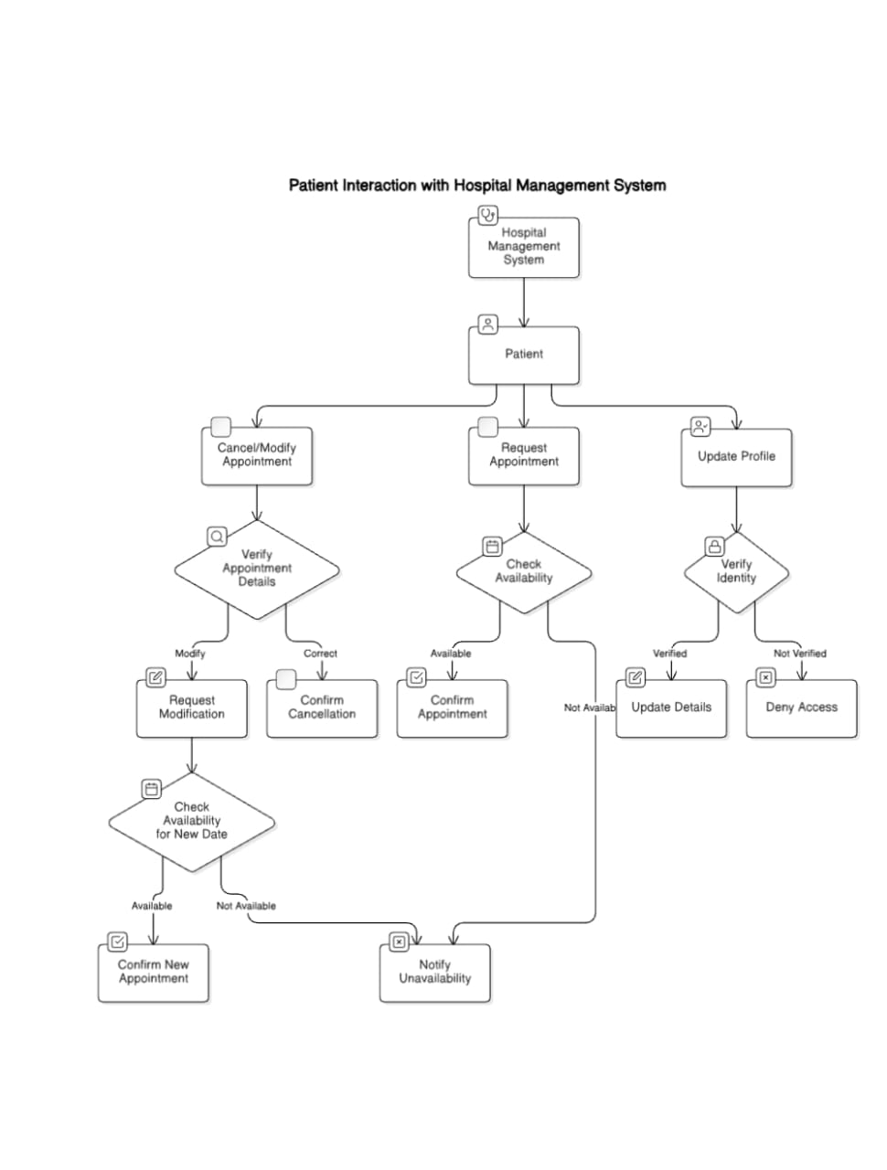

2.2 System Activity Diagrams
Each user role has an activity diagram that reflects the key tasks performed, such as managing appointments for doctors and profile management for patients.

2.3 System Sequence Diagrams
Sequence diagrams will detail the interactions between users and the system for various operations, such as:
- Admin managing user profiles.
- Doctor approving appointments.
- Patient requesting an appointment.

3. Backend Design

3.1 Data Description
The backend design is based on a relational database (MySQL/PostgreSQL), which includes tables for:
- Users (Admin, Doctor, Patient)
- Appointments
- Medical Records

3.2 Data Dictionary
- Users Table:
  - UserID: Unique identifier.
  - Name: Full name of the user.
  - Role: Type of user (Admin, Doctor, Patient).

- Appointments Table:
  - AppointmentID: Unique identifier.
  - DoctorID: Associated Doctor.
  - PatientID: Associated Patient.
  - Status: Pending, Approved, Canceled.

4. Front-end / User Interface Design

4.1 Overview of User Interface
The UI is designed to be responsive, using ReactJS for the front-end. It will adjust to different devices and screen sizes.

4.2 Screen Images
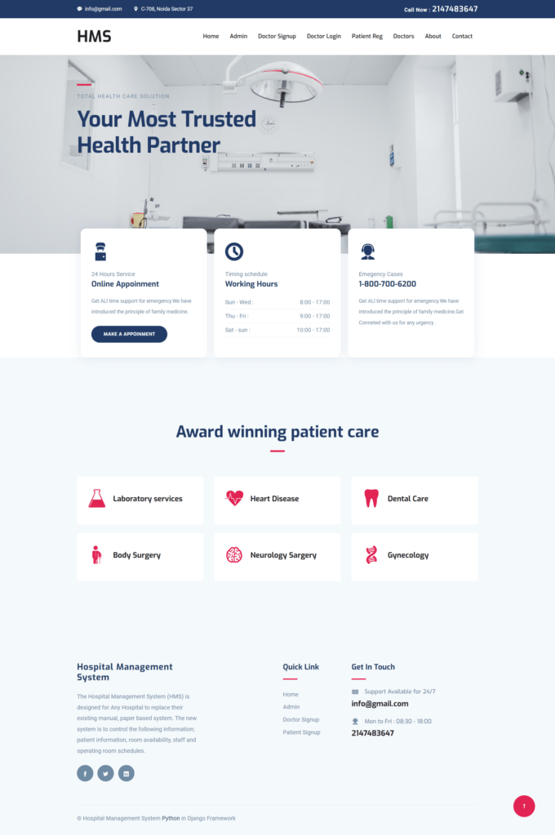

- Admin Dashboard: Overview of all hospital operations.
- Doctor Dashboard: Appointment schedules and patient management.
- Patient Dashboard: Personal appointments and profile settings.

4.3 Screen Objects and Actions
- Login Form: Allows users to sign in using their credentials.
- Appointment Form: Allows patients to schedule or cancel appointments.
- Profile Settings: Lets users update their contact details and passwords

5. System Architecture

5.1 Architectural Design
The architecture is based on a Client-Server Model. The frontend is built with ReactJS, while the backend is developed using Django. Communication between the two occurs via REST APIs.

5.2 Decomposition Description
The system is divided into modules such as:
- User Management: Admin manages users, appointments, and doctors.
- Appointment Management: Doctors and patients manage appointments.
- Profile Management: All users manage their personal settings.

5.3 Design Rationale
The system uses a modular and scalable architecture to ensure future extensibility. This helps in easily adding new features and modules in the future.

6. Component Design/System Architecture
The system is built with three main components: Backend, Frontend, and Database.

1. Backend: Django Framework
The Backend is built using Django, a Python web framework. It helps handle requests, manage users, and process data from the database.
- Handles Requests: Manages how data is sent and received between the server and the user.
- Built-in Features: Django has tools for user authentication, security, and managing databases.
- Scalable: It can handle a growing number of users and data over time.

2. Frontend: ReactJS
The Frontend is developed using ReactJS, a JavaScript library for building dynamic user interfaces.
- User Interface: React helps create a smooth and interactive experience for users.
- Real-time Updates: React can update the webpage without reloading it, which makes the app feel fast and responsive.
- Component-based: The UI is built using reusable components that make the development process efficient and easy to maintain.

3. Database: MySQL/PostgreSQL
The Database stores all the data for the application. We use either MySQL or PostgreSQL, both are reliable and secure databases.
- Stores Data: Saves user information, product details, or other important data.
- Security: Both MySQL and PostgreSQL are secure, ensuring that data is protected.
- Scalable: As the app grows, these databases can handle large amounts of data efficiently.

4. Communication Between Frontend and Backend
The Frontend and Backend communicate through RESTful APIs. This allows the frontend to send requests and get data from the backend.

7. APPENDICES
Appendices include:
- Database schemas.
- API documentation for frontend-backend communication.
- Test cases for system validation.

